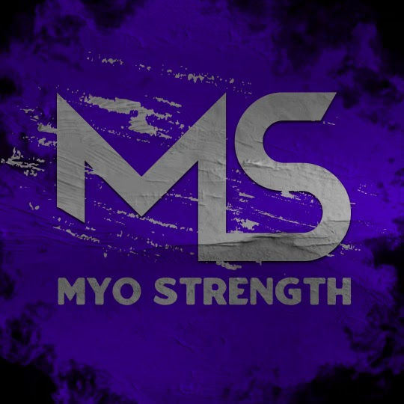
Client’s Name:
Address:
Sex:
Height:
Weight:
Birthday:

Goals

What are your goals? Please be specific about what you want, this can include health and physique goals.

Why do you feel like you’re dedicated to your goals now versus before? What is your “WHY” behind your goals?

How long have you been training and dieting for your current goal? How would you describe your experience?

Are there schedule limitations that may pose an issue in terms of training or meal prep?

If there are any negative past coaching experiences (or fitness related in general)?

How does a typical day look for you? (Include wake up/bed times, meal times/frequency, training times, work schedule, family time, hobbies, etc. - You can give a weekday and weekend example)

Medical Information

Have you ever had any injuries? List date of event, injury, and treatment

Do you have any allergies? If yes, please list (provide treatments too).

Are you on any medication? If yes, please give the name and dosage of medication.

Have you ever been diagnosed with heart disease or have heart issues? Y/N

Have you ever been diagnosed with diabetes or had issues with blood glucose, A1C or Insulin levels? Y/N

Please list other health issues.

Are you a smoker? Y/N If so how often do you smoke? (tobacco and marijuana)

Do you consume Alcohol? If so, how often? What kind?

Do you have a history of PED usage? If yes, please detail: 1) the drug, 2) the dosages, 3) the duration, 4) side effects. Did you PCT? Are you on HRT?

Please list other health issues. Explain when they started to happen and what treatments were done (prescription, OTC, etc.)

Have you ever had any surgeries/operations? If so, list date and type.

Please list any psychological issues and medications.

Do you have recent blood work completed? If so, please attach that as well.

Rate your current stress and sleep status and or provide a description.

What is your occupation? Are you sedentary? How does this impact stress?

How supportive is your S/O with hiring a coach? If not applicable, type N/A

Females only: Do you currently have a cycle? Is it consistent? What PMS symptoms do you have? Please be detailed

Do you have any skin issues?

Do you feel like you yawn frequently? Do you typically breathe through your mouth? Do you snore?

What do your bathroom habits look like? Do you experience bloating? Constipation? Diarrhea? Any excess gas or burping? Do you poop at least once a day? Multiple? Rate your stools using the Bristol Stool Chart.

Nutrition

Please provide a 48hr food log (2 days worth). Include approximate time of consumption and weight/quantity of ALL food and drink consumed. (all food and drink, including water) If you have a set caloric/macro intake or diet then you can list this instead.

Are you intolerant to any type of food? Do you follow a specific diet (paleo, vegan, vegetarian, etc.)?

Are you currently taking any supplements (including medication) or Vitamins? If so, please list the brand and dosage.

Do you have experience with following meal plans? Do you have experience counting macros?

Do you prefer following a meal plan? Macros? Both?

How long have you been on your current intake? What was the goal of this intake and were you successful? Elaborate.

Do you have any known digestive issues? Any issues with bloating, constipation, diarrhea, etc?

Are there specific foods you like or do not like? This is helpful when creating a meal plan/partial meal plan?

In this current intake, have you been gaining, maintaining, or losing weight?

How much caffeine do you consume on a daily basis? From what sources? (Coffee, stim pre-workouts, energy drinks, etc.)

What has your dieting history looked like? Meaning, how long have you been dieting, trying to diet, etc.? Or how long have you been outside of a deficit?

Current Work Out Regimen

Please let me know the frequency, volume, intensity etc of your training? Include anything that may be helpful.

Are you doing any cardio at this time? If so, please list type and time.

How many steps do you get on average daily?

Pictures

Provide front back and side angles in shorts or underwear. Females please use a sports bra, swimsuit top or something similar for a top. Please send to Coach Ash via e-mail or WhatApp, depending on your coaching plan. Examples can be found HERE

Communication - What is your preferred style of receiving feedback and communication? To you prefer blunt and to the point? Do you need more empathy in how I communicate?

If there is anything additional you feel I should know please list it here.

